AWS Task 1
Task:
Create a windows VM machine in AWS and connect with RDP open CMD in windows share the about system info.
Prerequisite:
- AWS
- RDP
Step-by-Step Guide:
- Launch a Windows EC2 Instance
- Log in to the AWS Management Console. Go to EC2 → Click Launch Instance. Fill in the details - Name: Windows-VM, AMI: Choose Microsoft Windows Server (ex: Windows Server 2019 Base), Instance Type: t2.micro (Free Tier eligible), Key Pair: Create/download a key pair (.pem) and Click Launch Instance.
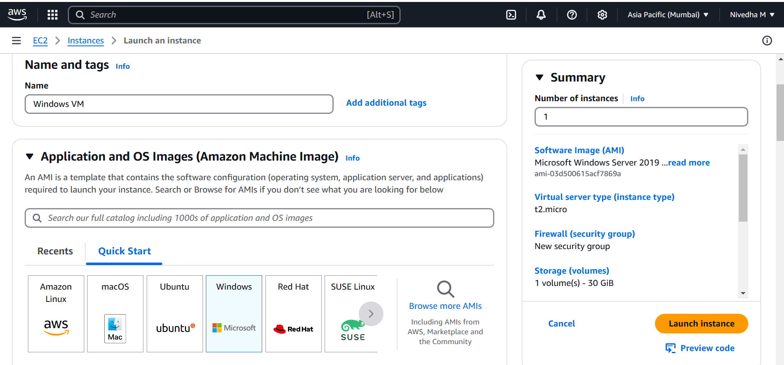
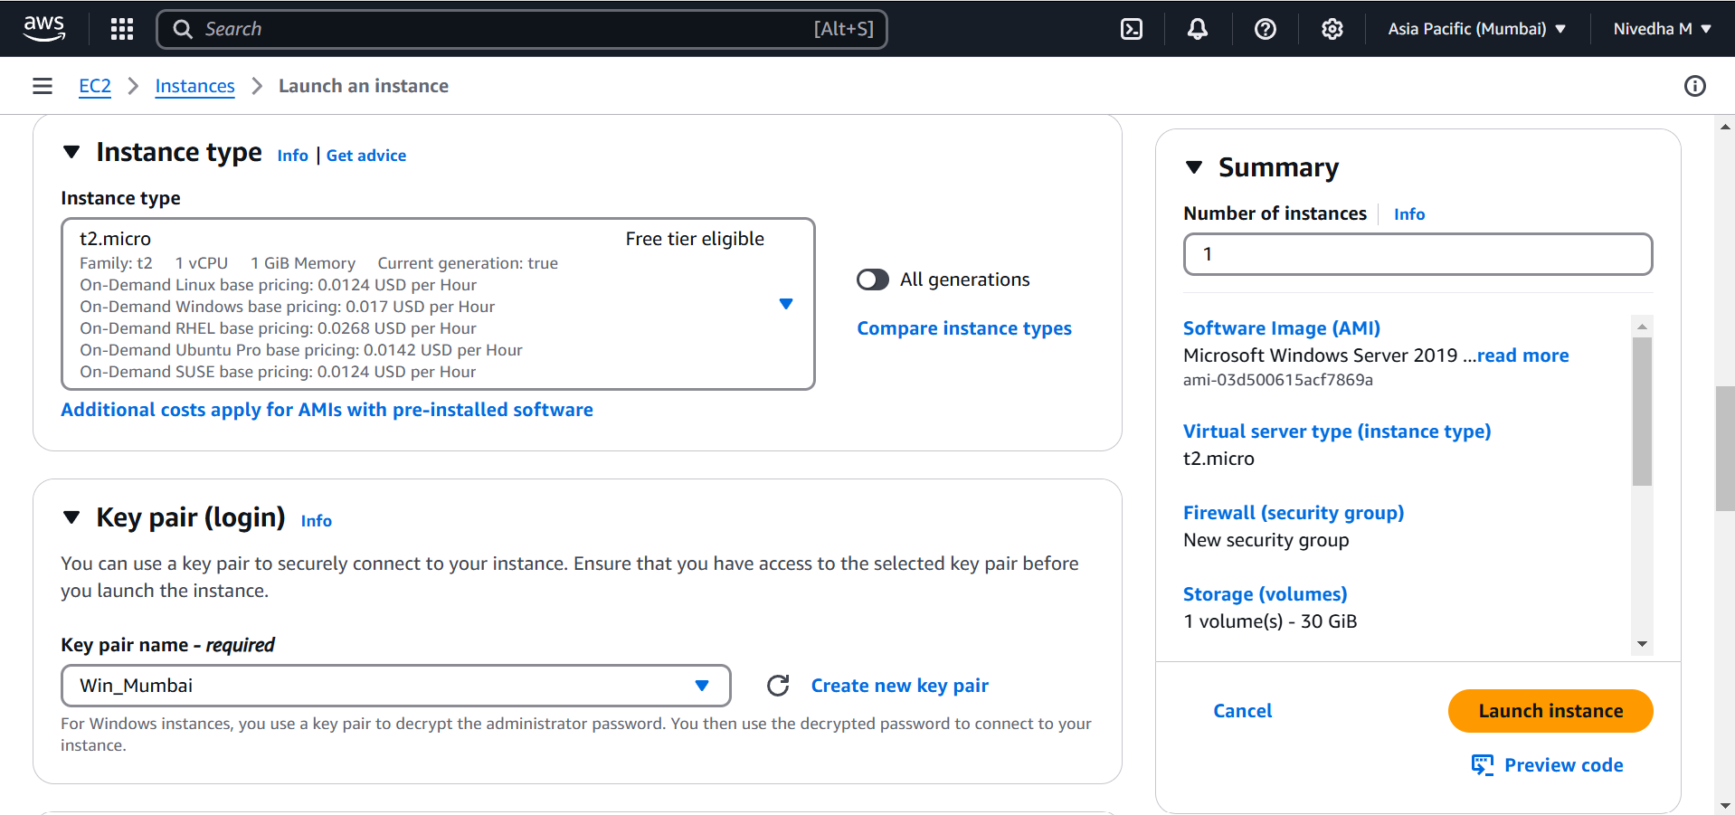

- Connect Using RDP (Remote Desktop)
- Once the instance is running - Select the instance → Click Connect. Under the RDP Client tab - Click Get Password → Upload your .pem key. Decrypt to get username and password.

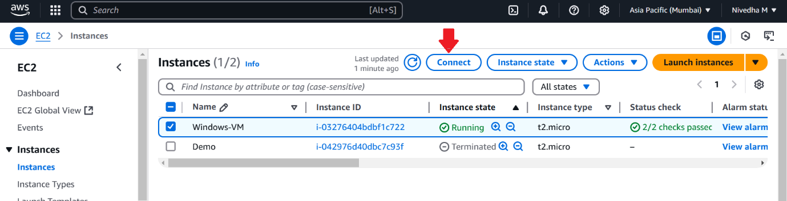

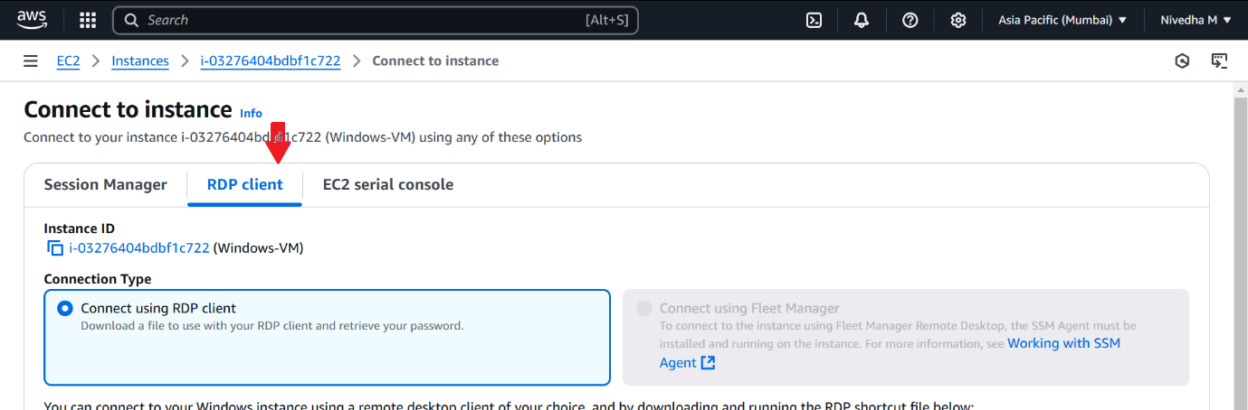

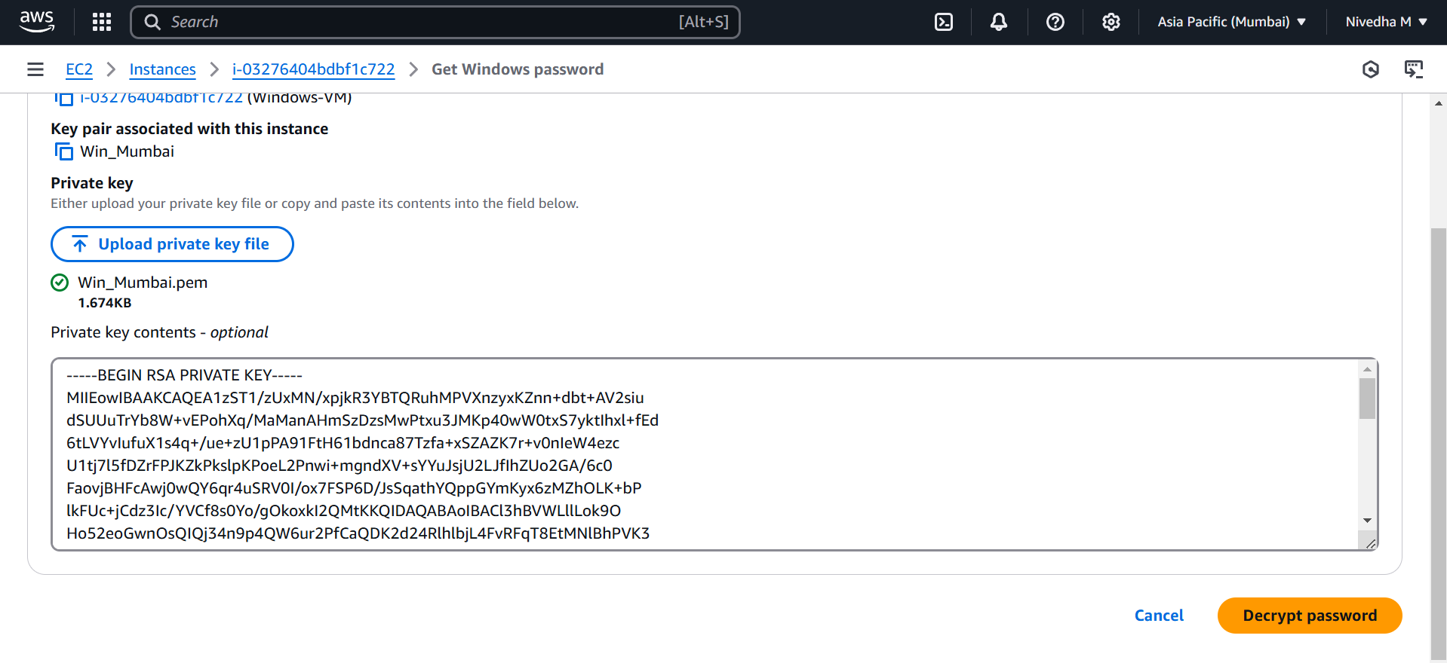
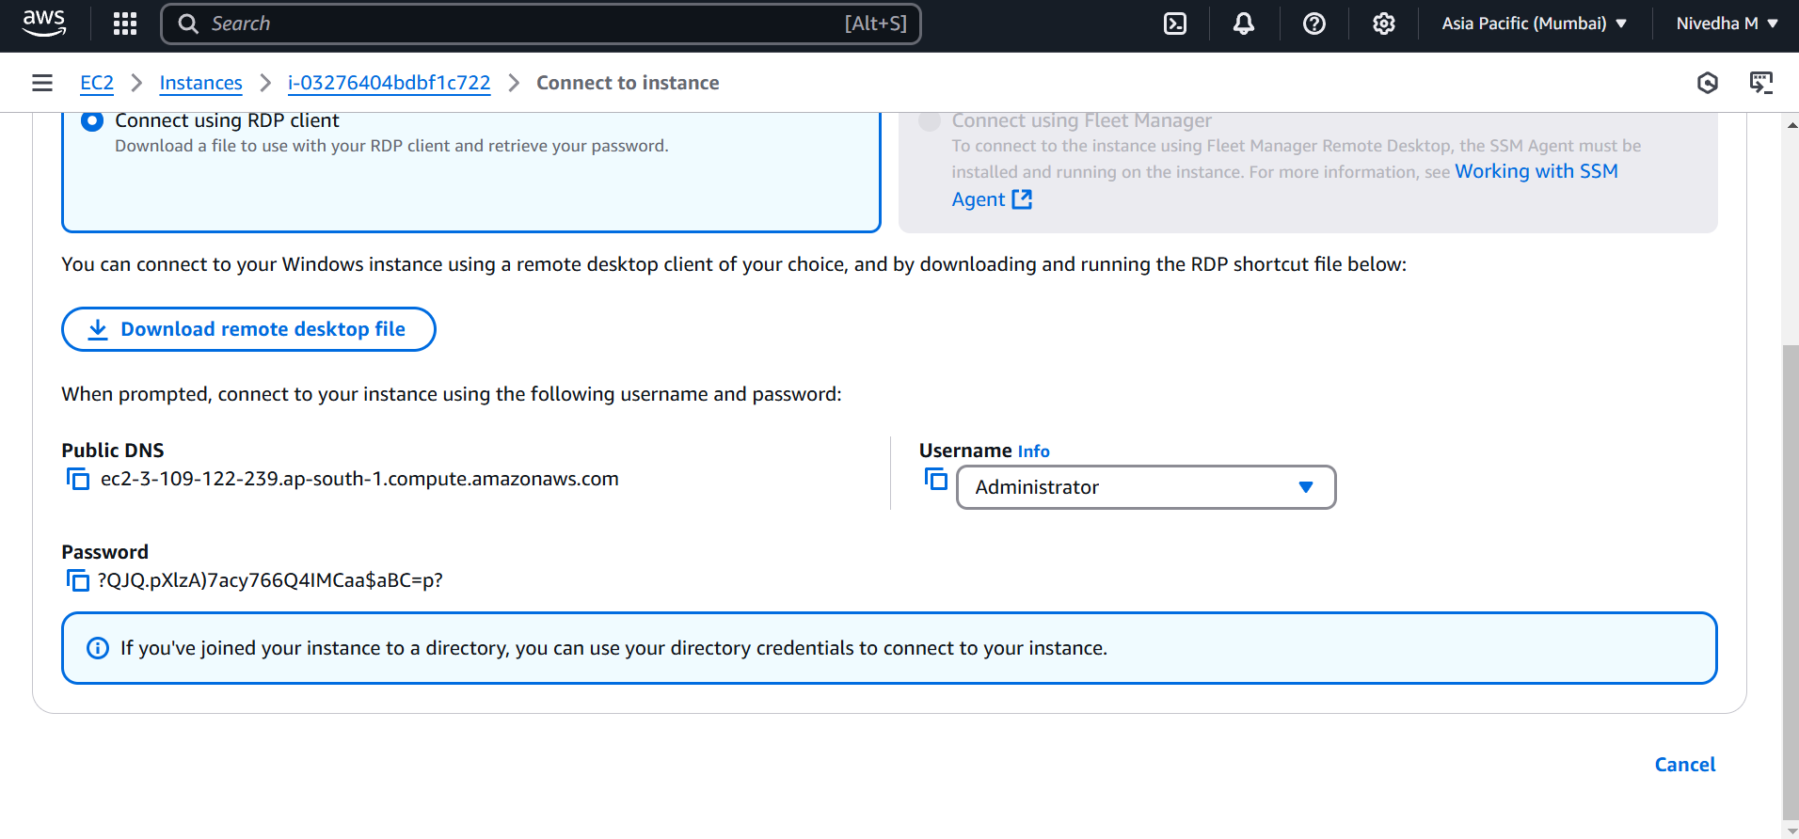
- Open Remote Desktop Connection on your local Windows machine - Press Win + R → Type mstsc → Hit Enter. Paste the Public IPv4 address of the instance. Enter the username (usually Administrator) and password and Click Connect.
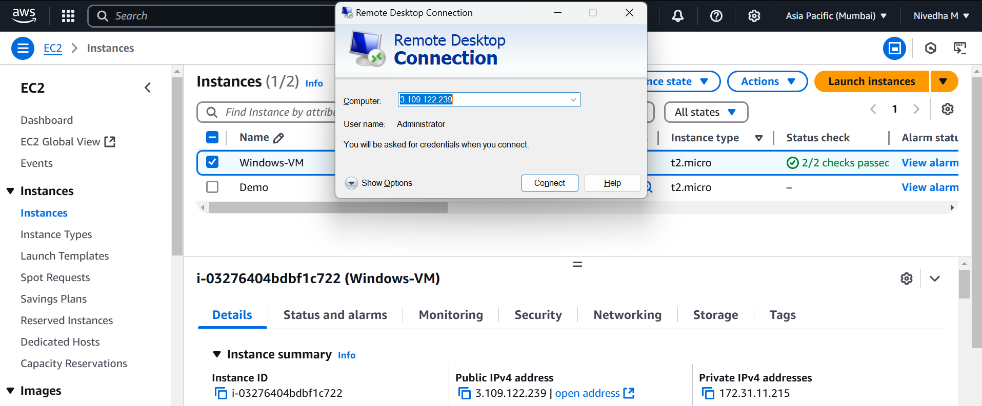
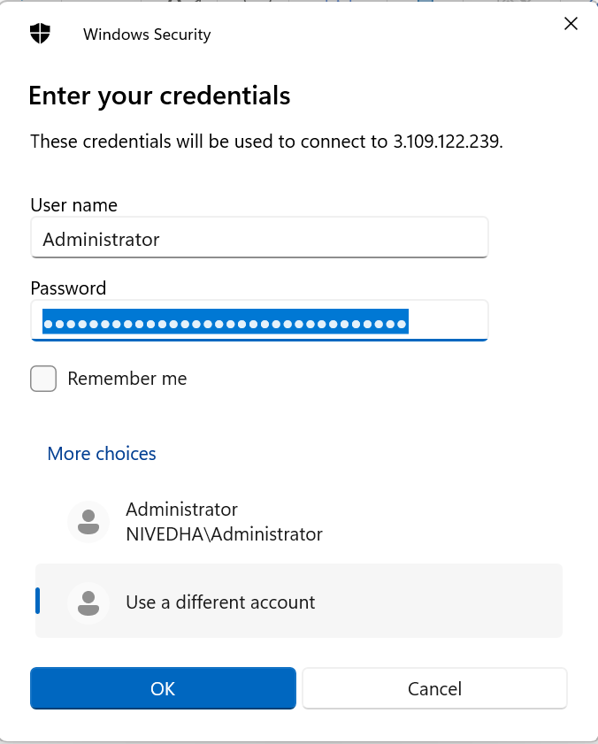

- Open CMD & View System Info
- Once you're in – Press Win button and type CMD and open it. Run the following command: systeminfo. It shows everything about your Windows VM:
OS Version, CPU, RAM, Network config, Boot time, etc.

